# 1. 设置ModerAndView

## 1看是否是springboot 或者spring mvc的路径，下面这个是spring boot

@RequestMapping(value = **"/mng/login"** ,method = RequestMethod.***GET***)  
**public** ModelAndView findall(){  
 **testSqlite** = **new** TestSQLite();  
 ModelAndView mv = **new** ModelAndView(**"find"**); html文件名称  
 List<Mnxra> mnxras = **testSqlite**.queryAll();   
 mv.addObject(**"mnxras"**,mnxras);  
 **return** mv;  
}

## 2. mv.setViewName("和上文其实是一样的")

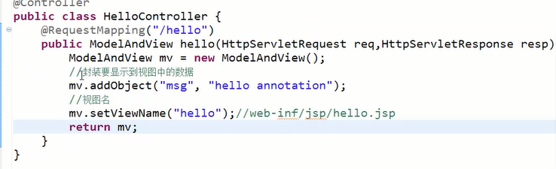

# 2.response.getWriter().println("")

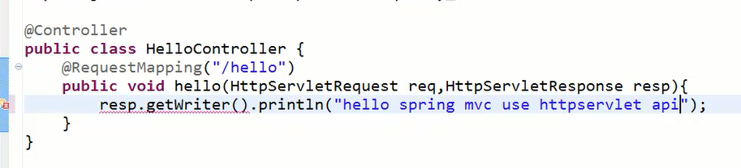

# 3. response.sendRedirect("/jsp/hello.jsp");

@RequestMapping(value="/hi1.do")

**public** **void** hello(HttpServletRequest req,HttpServletResponse resp) **throws** ServletException, IOException{

//req.getRequestDispatcher("/index.jsp").forward(req, resp);

resp.sendRedirect("/jsp/hello.jsp");

}

# 4. request.getRequestDispatcher

@RequestMapping(value="/hi1.do")

**public** **void** hello(HttpServletRequest req,HttpServletResponse resp) **throws** ServletException, IOException{

req.getRequestDispatcher("/index.jsp").forward(req, resp);

}

# 5. return "forward:index.jsp";

@RequestMapping("/hi2.do")

**public** String hello2(ModelMap map){

**return** "forward:index.jsp";

}

# 6. "redirect:/WEB-INF/jsp/hello.jsp 重定向

@RequestMapping("/hi3.do")

**public** String hello3(ModelMap map){

map.addAttribute("msg", "helloworld");

**return** "redirect:/WEB-INF/jsp/hello.jsp";

}

# 7.spring boot中学习 redirect 加/是绝对路径，不加是相对路径

@GetMapping( {**"/"**, **"index.html"**})  
**public** ModelAndView dashboard() {  
 Subject currentUser = SecurityUtils.*getSubject*();  
 ***logger***.info(**request**.getServerName());  
 ***logger***.info(**"Show unitInformation"**);  
 UserPrincipal userPrincipal = (UserPrincipal) currentUser.getPrincipal();  
 ModelAndView mav = **new** ModelAndView();  
 HttpSession session= **request**.getSession();  
 *//身份信息放入session* ***logger***.info(userPrincipal+**"***"**+userPrincipal.getRole()+**"***"**+userPrincipal.getDepName());  
 session.setAttribute(**"user"**,userPrincipal);  
 **if** (userPrincipal.getRole().equals(**"STUDENT"**)){  
 mav.setViewName(**"redirect:/stuIndex.html"**);  
 }**else if**(userPrincipal.getRole().equals(**"COMPANY"**)){  
 mav.setViewName(**"companyHTML/index"**);  
 }**else if** (userPrincipal.getRole().equals(**"TEACHER"**)){  
 mav.setViewName(**"redirect:/teacherIndex.html"**);  
 }  
 **return** mav;